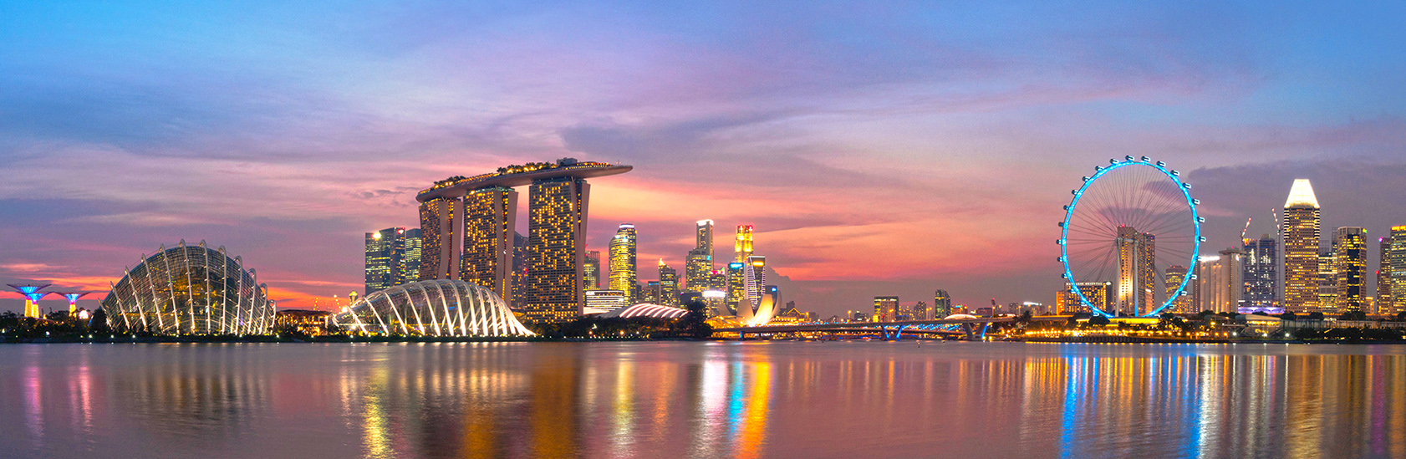

**Organizing Committee**  
**Honorary Chairs**

Ming-Ting Sun, Univ. of Washington, USA  
Shih-Fu Chang, Columbia Univ., USA

**General Chairs**

Chang Wen Chen, SUNY Buffalo, USA   
Yap-Peng Tan, NTU, Singapore

**Program Chairs**

Dan Schonfeld, Univ. of Illinois Chicago, USA  
Junsong Yuan, NTU, Singapore

# Emerging Techniques for Next Generation Video/Image Coding

* Content- and context-adaptive coding techniques
* Joint codec optimization w/ context information
* Parallel-friendly coding algorithms
* Perceptual coding and quality assessment
* Non-traditional coding techniques
* Representation and analysis of visual signals

# Advanced Techniques for Emerging 3D Videos

* Representation, analysis and coding of 3D scenes
* Multi-view video processing and coding
* 3D videos and free viewpoint TV
* 2D to 3D video conversion
* Graphics representations and content creation

# Visual Communications

* Video streaming and networking systems
* Internet video and QoS issues
* Video on demand and live video services
* Wireless and broadband videos
* Secure and robust video transmissions

**Special Session Chairs**

Chia-Wen Lin, National Tsinghua Univ., Taiwan   
Jiwen Lu, ADSC, Singapore

**Tutorial Chairs**

Dong Xu, NTU, Singapore  
Zicheng Liu, Microsoft Research, USA

**Panel Chairs**

Shuicheng Yan, NUS, Singapore  
Wenjun Zeng, Univ. of Missouri-Columbia, USA

**Demo Chairs**

Gang Wang, NTU, Singapore   
Lingyu Duan, Peking Univ., China

**Award Chairs**

Jiebo Luo, Univ. of Rochester, USA  
Yen-Kuang Chen, Intel Corporation, USA

**Publication Chairs**

Kim Hui Yap, NTU, Singapore  
Ying Wu, Northwestern Univ., USA

**Publicity Chairs**

Enrico Magli, Politecnico di Torino, Italy  
Nikolaos Boulgouris, Brunel Univ., UK   
Tihao Chiang, Ambarella, Taiwan

**Local Arrangement Chairs**

Andy Khong, NTU, Singapore  
Stefan Winkler, ADSC, Singapore

**Finance Chair**

Jingjing Meng, NTU, Singapore

**Sponsors**







**IEEE VCIP 2015**

**Visual Communications and Image Processing**

**13 – 16 December 2015, Singapore**

**Call For Papers**

The IEEE International Conference on Visual Communications and Image Processing (VCIP), sponsored by the IEEE Circuits and Systems Society and supported by the School of Electrical & Electronic Engineering, Nanyang Technological University (NTU), will be held in Singapore during 13 - 16 December 2015.

VCIP has served as a premier forum in SPIE and IEEE for the exchange of fundamental research results and technological advances in the field of visual communications and image processing since 1986. It provides a venue for leading engineers and scientists from around the world to advance the research frontiers in various areas of interest to VCIP. Original and unpublished works relevant to, but not limited to, the following topics are hereby solicited.

# Systems and Techniques for Human Interaction

* Mobile visual search
* Futuristic human-machine interfaces
* Multimodal recognition for mixed reality
* Natural image to 2D/3D virtual translation
* Display design for mixed reality
* Virtually real and mixed reality applications
* Biomedical imaging

# Embedded Systems and Architecture Implementations

* Concurrent algorithm/architecture optimization
* Embedded software on DSP, ASIP, VLIW, multi-core CPU, GPU, etc.
* Architecture based design on VLSI, FPGA, reconfigurable architectures, SoC, etc.

# Cloud Multimedia Systems, Applications & Services

* Infrastructure for media storage/distribution & computing
* Performance metrics for multimedia processing in clouds
* Large-scale multimedia content processing and analysis
* Complex semantic multimedia computing in clouds
* Mobile applications and services over clouds

**Submission of Papers:** Prospective authors are invited to submit a 4-page, full-length paper, including results, figures, and references. VCIP 2015 also encourages the submission of one-page demo papers with a description of proposed working systems. Only electronic submissions will be accepted via the conference website at <http://www.vcip2015.org>. Papers accepted for regular, special, and demo sessions must be registered and presented to assure their inclusion in the IEEE Xplore Library. Awards will be presented to a number of papers with best quality.

**Tutorial and Special Session Proposals:** Researchers, developers, and practitioners from related communities are invited to submit proposals for organizing tutorials and special sessions on various emerging topics described above. Tutorials will be held on Sunday, 13 December 2015. Each tutorial proposal must include a title, outline, contact and biography information of the presenter(s), and short description of the material to be distributed. Each special session proposal must provide a title, rationale, contact and biography information of the organizer(s), and a list of possible papers with contributing authors, tentative titles and abstracts. Special session papers will be peer reviewed. Please visit the conference website for proposal submission details.

**Important Due Dates:**

Tutorial & Special Session Proposals 15 April 2015

Paper Submissions ~~15 May 2015~~ 8 June 2015

Notification of Acceptance ~~15 August 2015~~ 5 September 2015

Submission of Camera-Ready Papers ~~12 September 2015~~ 25 September 2015

http://www.vcip2015.org